Supporting Information
for
An enantioselective double Diels-Alder approach to the tetracyclic framework of colombiasin A

Jason H. Chaplin, Alison J. Edwards and Bernard L. Flynn

Melting points were recorded with a Kofler hot-stage apparatus and are uncorrected. Proton (¹H) and carbon (¹³C) NMR spectra were recorded with a Varian Gemini 300 spectrometer operating at 300 MHz for proton and 75 MHz for carbon, unless otherwise stated. All NMR spectra were recorded in (D)chloroform (CDCl₃) at 20 °C. The protonicities of the carbon atoms observed in the carbon NMR were determined using attached proton test (APT) experiments. Infrared spectra (IR) were obtained as KBr discs or as films on KBr plates and were recorded on a Perkin-Elmer Spectrum One Fourier-transform infrared spectrophotometer. Low-resolution electron impact mass spectra (MS) were recorded at 70 eV on either a VG micromass 7070F instrument or a JEOL AX-505H mass spectrometer, unless otherwise stated. High-resolution mass spectra (HRMS) were recorded on a VG micromass 7070F instrument. Tetrahydrofuran (THF) was distilled under nitrogen from sodium benzophenone ketyl. Dichloromethane was distilled from calcium hydride. All experiments were performed under an anhydrous atmosphere of N₂ (g) except as indicated. Flash chromatography was performed on Merck Kieselgel 60 unless otherwise stated.

(3E, 7E)-deca-3,7-diene-2,9-dione (3)
This compound 3 was prepared from 2,5-dimethoxytetrahydrofuran using previously described methods (reference [8] main text).

(3E, 7E)-2,9-dimethyldeca-1,3,7,9-tetraene (4)
To a stirred suspension of dry methyltriphenylphosphonium bromide (5.50 g, 15.4 mmol, dried under vacuum at 110°C for 3 hours) in dry THF (20 ml) at 0°C was added n-BuLi (15.4 mmol) and the resulting red suspension was allowed to warm to room temperature. Stirring was continued until no visible unreacted phosphonium salt remained, at which point the solution was cooled to -78°C and a THF solution (5 ml) of dienone 3 (1.16 g, 7.00 mmol) was added. The reaction was allowed to warm slowly to room temperature, concentrated in vacuo and the residue washed with hexanes and filtered to remove the bulk of the triphenylphosphine oxide by-product. The filtrate was evaporated onto silica-gel (~1 g) and chromatographed (silica gel, hexanes) to give the diene 4 as a colourless oil (500 mg, 44% yield). ¹H-NMR (300 MHz, CDCl₃): δ 6.19 (d, J = 15.6 Hz, 2H), 5.69 (m_{c}, 2H), 4.90 (s, 4H), 2.24 (m_{c}, 4H), 1.85 (d, J = 1.2 Hz, 6H). ¹³C-NMR + APT (75 MHz, CDCl₃): δ 142.0 (2 x C), 133.2 (2 x CH), 129.8 (2 x CH), 114.5 (2 x CH₂), 32.7 (2 x CH₂), 18.6 (2 x CH₃). IR (neat, cm⁻¹): 3018, 2924, 2853, 1612, 1450, 1375, 964, 883. LRMS m/z (%): 162 (15) M⁺, 147 (25), 106 (20), 81 (100). HRMS calcd for C₁₂H₁₈: 162.1409. Found: 162.1407.

(3E, 7E)-9-t-butyldimethylsilyloxy-deca-3,7,9-triene-2-one
To a solution of dienone 3 (500 mg, 3.0 mmol) and NEt₃ (0.63 ml, 4.5 mmol) in dry CH₂Cl₂ (10 ml) at -78°C was added t-butyldimethylsilyl triflate (0.62 ml, 2.7 mmol) and the resulting mixture was allowed to warm to room temperature. The solution was concentrated onto alumina and chromatographed (alumina II, sequential elution: hexanes, 1% Et₂O, 5% Et₂O) to give three fractions containing 409 mg of disilylated material, 290 mg of the desired monosilylated compound (52% yield based on recovered starting material, colourless oil) and 170 mg of the dienone 3 (34% recovery) starting material. ¹H-NMR (300 MHz, CDCl₃): δ 6.79 (dt, J = 15, 6 Hz, 1H), 6.09 (d, J = 15 Hz, 1H), 5.96-5.87 (m, 2H), 4.24 (d, J = 3.9 Hz, 2H), 2.39-2.22 (m, 4H), 2.24 (s, 3H), 0.96 (s, 9H), 0.17 (s, 6H). ¹³C-NMR + APT (75 MHz, CDCl₃): δ 198.1 (C), 154.5 (C), 147.0 (CH), 131.5 (CH), 129.1 (CH), 128.8 (CH), 94.5 (CH₂), 31.9 (CH₂), 30.3 (CH₂), 26.6 (CH₃), 25.6 (3 x CH₃), 18.1 (C), -4.9 (2 x CH₃). IR (neat, cm⁻¹): 2930, 2897, 2858, 1699, 1678, 1628, 1593, 1470, 1362, 1319, 1294, 1254, 1024, 1005, 964, 827, 810, 781. LRMS m/z (%): 280 (20) M⁺, 195 (50), 151 (65), 143 (55), 133 (55), 123 (95), 111 (80), 95 (55), 83 (100). HRMS calcd for C₁₆H₂₈O₂Si: 280.1859. Found: 280.1860.

(3E, 7E)-2,9-di-t-butyldimethylsilyloxydeca-1,3,7,9-tetraene
¹H-NMR (300 MHz, CDCl₃): δ 6.02-5.85 (m, 4H), 4.21 (d, J = 3.6 Hz, 4H), 2.22-2.19 (m, 4H), 0.96 (s, 18H), 0.17 (s, 12H). ¹³C-NMR + APT (75 MHz, CDCl₃): δ 155.0 (2 x C), 130.6 (2 x CH), 128.4 (2 x CH), 94.1 (2 x CH₂), 31.8 (2 x CH₂), 25.8 (6 x CH₃), 18.3 (2 x C), -4.7 (4 x CH₃). IR (neat, cm⁻¹): 2930, 2897, 2856, 1649, 1591, 1472, 1462, 1362, 1327, 1286, 1256, 1165, 1024, 1005, 964, 939, 827, 806, 781, 692. LRMS m/z (%): 394 (5) M⁺, 379 (14), 337 (75), 263 (90), 205 (30), 147 (60), 125 (35), 73 (100). HRMS calcd for C₂₂H₄₂O₂Si₂: 394.2723. Found: 394.2722.

(3E, 7E)-2-t-butyldimethylsilyloxy-9-methyl-deca-1,3,7,9-tetraene (5)
To a stirred suspension of methyltriphenylphosphonium bromide (535 mg, 1.50 mmol) in dry THF (10 ml) at 0°C was added n-BuLi (1.5 mmol) and the resulting red mixture was allowed to warm to room temperature. After no visible unreacted phosphonium salt remained the solution was cooled to -78°C and was treated with a solution of enone (281 mg, 1.00 mmol) in THF (10 ml, precooled to -78°C, added via cannula). The resulting reaction was allowed to warm to room temperature and then quenched with water (30 ml) and extracted with Et₂O (50 ml). The organic layer was dried over MgSO₄, concentrated onto alumina and chromatographed through an alumina column (alumina II, hexanes). Concentration of the relevant fractions gave the product diene 5 as a colourless oil (234 mg, 84% yield). ¹H-NMR (300 MHz, CDCl₃): δ 6.16 (d, J = 15.6 Hz, 1H), 6.04-5.98 (m, 1H), 5.90 (d, J = 15.6 Hz, 1H), 5.65 (m_{c}, 1H), 4.87 (s, 2H), 4.22 (s, 2H), 2.23-2.19 (m, 4H), 1.82 (s, 3H), 0.96 (s, 9H), 0.17 (s, 6H). ¹³C-NMR + APT (75 MHz, CDCl₃): δ 155.0 (C), 141.9 (C), 133.3 (CH), 130.8 (CH), 129.7 (CH), 128.1(CH), 114.5 (CH₂), 94.1 (CH₂), 32.4 (CH₂), 31.9 (CH₂), 25.7 (3 x CH₃), 18.6 (CH₃), 18.2 (C), -4.7 (2 x CH₃). IR (neat, cm⁻¹) = 2924, 2856, 1653, 1593, 1460, 1315, 1254, 1024, 962, 837, 781, 691. LRMS m/z (%): 278 (15) M⁺, 263 (25), 221 (55), 145 (55), 125 (40), 75 (100). HRMS calcd for C₁₇H₃₀OSi: 278.2066. Found: 278.2065.

Rac-2-(phenylsulfinyl)-1,4-naphthoquinone (6)
The sulfinylnaphthoquinone 6 was prepared from 1,4-naphthoquinone 2 using previously described methods (reference [9] main text).

1,4-Dihydro-1-(5-methyl-hexa-3,5-dienyl)-3-methyl-anthraquinone (7)
To a solution of the symmetrical double diene 4 (82 mg, 0.505 mmol) in dry CH₂Cl₂ (1.5 ml) at -15°C was added a solution of napthosulfoxide 6 (143 mg, 0.507 mmol) in dry CH₂Cl₂ (1.5 ml) and the reaction allowed to warm to room temperature overnight. A precipitate formed during this period and was isolated by filtration and identified as the hydroquinone of the napthosulfoxide 9 (41 mg, 29% of starting material). The filtrate was concentrated onto silica-gel (~0.5 g) and chromatographed (sequential elution: hexanes, 5% Et₂O in hexanes, 10% Et₂O, 20% Et₂O). The first eluted fractions were concentrated to give 18 mg of the starting double-diene 4 (22% recovery) while the second set of fractions afforded the mono-Diels-Alder adduct 7 as a yellow oil (46 mg, 29% yield, 37% based on recovered starting material). ¹H-NMR (300 MHz, CDCl₃): δ 8.09-8.04 (m, 2H), 7.72-7.66 (m, 2H), 6.09 (d, J = 15.3 Hz, 1H), 5.62-5.52 (m, 2H), 4.80 (s, 2H), 3.68 (m_{c}, 1H), 3.23 (dd, J = 23.1, 4.5 Hz, 1H), 2.99 (dd, J = 23.1, 6.0 Hz, 1H), 2.20-1.99 (m, 2H), 1.85 (s, 3H), 1.85-1.62 (m, 2H), 1.72 (s, 3H). ¹³C-NMR + APT (75 MHz, CDCl₃): δ 184.5 (C), 184.1 (C), 145.4 (C), 142.6 (C), 141.9 (C), 133.5 (CH), 133.4 (CH), 133.0 (CH), 132.3 (C), 132.0 (C), 130.6 (C), 130.2 (CH), 126.3 (CH), 126.1 (CH), 122.1 (CH), 114.5 (CH₂), 35.1 (CH₂), 35.0 (CH), 29.6 (CH₂), 29.1 (CH₂), 22.8 (CH₃), 18.5 (CH₃). IR (neat, cm⁻¹): 2964, 2924, 2858, 1726, 1661, 1624, 1595, 1450, 1412, 1329, 1292, 964, 912, 881, 733. LRMS m/z (%): 318 (5) M⁺, 236 (15), 224 (100), 209 (30), 181 (10), 165 (35), 152 (25), 91 (15). HRMS calcd for C₂₂H₂₂O₂: 318.1620. Found: 318.1618.

DA-E-IMDA product 8
The mono-Diels-Alder adduct 7 (26 mg, 0.082 mmol) was dissolved in dry toluene (2 ml) and the solution degassed by bubbling through a stream of N₂. The solution was heated to 160-170C for 5 hours (sealed tube), cooled and concentrated onto silica-gel (~0.5 g) and chromatographed (10% Et₂O) to give the double-Diels-Alder adduct 8 as a resinous gum. The material was crystallized by standing in MeOH (1 ml) at 4°C (21 mg, 81% yield, mp = 145-7°C). ¹H-NMR (300 MHz, CDCl₃): δ 8.07-8.00 (m, 1H), 7.98-7.90 (m, 1H), 7.73-7.65 (m, 2H), 5.80 (s, 1H), 5.16 (s, 1H), 3.00 (d, J = 17.1 Hz, 1H), 2.89-2.77 (m, 1H), 2.58-2.49 (m, 1H), 2.35-2.16 (m, 2H), 2.06-1.83 (m, 4H), 1.71 (s, 3H), 1.57 (s, 3H), 1.60-1.49 (m, 1H). ¹³C-NMR + APT (75 MHz, CDCl₃): δ 199.6 (C), 199.2 (C), 134.2 (CH), 133.8 (CH), 133.5 (C), 131.9 (C), 129.9 (C), 129.5 (C), 127.1 (CH), 126.9 (CH), 124.9 (CH), 124.2 (CH), 61.2 (C), 51.3 (C), 40.2 (CH), 40.1 (CH), 40.0 (CH₂), 32.5 (CH₂), 30.1, (CH₂), 25.6 (CH₂), 23.8 (CH₃), 22.8 (CH₃). IR (KBr disc, cm⁻¹): 2871, 1687, 1589, 1429, 1277, 1212, 1157, 1006, 784, 719. LRMS m/z (%): 318 (100) M⁺, 303 (15), 285 (30), 237 (55), 223 (85), 185 (20), 174 (55), 165 (20), 145 (35), 134 (20), 105 (20), 77 (15). HRMS calcd for C₂₂H₂₂O₂: 318.1620. Found: 318.1617.

2-(phenylsulfinyl)-1,4-naphthalenediol (9)
¹H-NMR (300 MHz, d⁶-DMSO): δ 10.04 (br. s, 1H), 9.93 (br. s, 1H), 8.21-8.04 (m, 2H), 7.72-7.40 (m, 7H), 6.96 (s, 1H). ¹³C-NMR + APT (75 MHz, d⁶-DMSO): δ 147.6 (2 x C), 146.2 (C), 142.8 (C), 130.6 (CH), 129.3 (CH), 126.8 (CH), 126.7 (C), 126.3 (CH), 126.2 (C) 124.2 (CH), 122.5 (CH), 122.4 (CH), 100.3 (CH). LRMS m/z (%): 284 M⁺ (30), 266 (100), 237 (40), 189 (45), 158 (65), 126 (35), 104 (60), 78 (70). HRMS calcd for C₁₆H₁₂O₄S: 284.0507. Found: 284.0509.

1,4-Dihydro-1-(5-methyl-hexa-3,5-dienyl)-3-(t-butyldimethylsilyloxy)-anthraquinone (10)
To a solution of the naphthosulfoxide 6 (54 mg, 0.19 mmol) in CH₂Cl₂ (2 ml) at -15C was added double-diene 5 (53 mg, 0.19 mmol) and the resulting reaction mixture was allowed to warm to room temperature and stir for 15 minutes. A precipitate formed during the reaction and was collected by filtration. Spectral analysis of this material identified it as the reduced dienophile 9. Silica-gel column chromatography of the filtrate (5% Et₂O in hexanes) gave the mono-Diels-Alder product 10 as a yellow oil (45 mg, 55% yield). ¹H-NMR (300 MHz, d⁶-acetone): δ 8.11-8.03 (m, 2H), 7.88-7.82 (m, 2H), 6.15 (d, J = 15.6 Hz, 1H), 5.67 (dt, J = 15.6, 7.2 Hz), 5.12-5.09 (m, 1H), 4.82 (s, 2H), 3.82 (m_{c}, 1H), 3.23 (m_{c}, 2H), 2.20 (m_{c}, 2H), 1.88-1.79 (m, 2H), 1.73 (s, 3H), 1.03 (s, 9H), 0.30 (s, 3H), 0.29 (s, 3H). ¹³C-NMR + APT (75 MHz, d⁶-acetone): δ 184.2 (2 x C), 148.4 (C), 145.4 (C), 142.6 (C), 142.5 (C), 134.4 (CH), 134.3 (CH), 133.7 (CH), 133.1 (C), 132.8 (C), 131.0 (CH), 126.8 (CH), 126.5 (CH), 114.8 (CH₂), 104.7 (CH), 36.3 (CH), 36.2 (CH₂), 29.9 (CH₂), 29.6 (CH₂), 25.9 (3 x CH₃), 18.5 (CH₃), 18.5 (C), -4.2 (CH₃), -4.4 (CH₃). IR (neat, cm⁻¹): 2962, 2930, 2856, 1688, 1663, 1595, 1462, 1398, 1362, 1294, 1252, 1209, 1163, 964, 893, 839, 781. LRMS m/z (%): 434 (15) M⁺, 377 (85), 339 (100), 295 (20), 281 (30), 73 (99). HRMS calcd for C₂₇H₃₄O₃Si: 434.2277. Found: 434.2278.

DA-E-IMDA product 11
The mono-Diels-Alder adduct 10 (38 mg, 0.087 mmol) was dissolved in degassed toluene (10 ml) and heated to 160°C for 6 hours. The reaction was then cooled and concentrated onto alumina (activated with 1.2% water) and chromatographed (5% Et₂O in hexanes) to give the product 11 as a resinous material that solidified on standing in the freezer (27 mg, 71% yield, mp = 114-116°C). ¹H-NMR (300 MHz, CDCl₃): δ 8.09-8.04 (m, 1H), 7.98-7.92 (m, 1H), 7.72-7.66 (m, 2H), 5.80 (s, 1H), 4.66 (m_{c}, 1H), 3.09 (d, J = 17.5 Hz, 1H), 2.98-2.85 (m, 1H), 2.67-2.60 (m, 1H), 2.32-1.85 (m, 7H), 1.56 (s, 3H), 0.92 (s, 9H), 0.19 (s, 3H), 0.13 (s, 3H). ¹³C-NMR + APT (75 MHz, CDCl₃): δ 199.4 (C), 199.3 (C), 146.7 (C), 134.2 (CH), 133.8 (CH), 133.4 (C), 131.8 (C), 129.3 (C), 127.2 (CH), 126.9 (CH), 124.4 (CH), 108.8 (CH), 61.2 (C), 52.0 (C), 40.0 (CH), 39.9 (CH₂), 39.4 (CH), 32.5 (CH₂), 30.7 (CH₂), 25.7 (CH₂), 25.7 (3 x CH₃), 22.8 (CH₃), 18.0 (C), -4.3 (CH₃), -4.4 (CH₃). IR (KBr disc, cm⁻¹): 2927, 2855, 1692, 1666, 1590, 1472, 1434, 1350, 1275, 1253, 1214, 1194, 915, 853, 835, 776. LRMS m/z (%): 434 (100) M⁺, 419 (15), 391 (15), 377 (40), 359 (10), 340 (25), 261 (35), 174 (25), 73 (95). HRMS calcd for C₂₇H₃₄O₃Si: 434.2277. Found: 434.2280.

6-bromo-2,4-dimethoxy-3-methylphenol (12)
The bromide 12 was prepared using previously described methods (reference [11] main text).

(S)S-2,4-dimethoxy-3-methyl-6-p-tolylsulfinylphenol (14)
To a solution of bromide 12 (150 mg, 0.61 mmol) in dry THF (2 ml) at -78C was added n-BuLi (1.34 mmol) and the reaction allowed to warm to room temperature. After stirring for 15 minutes the solution was re-cooled to -78C and menthyl sulfinate 13 (214 mg, 0.73 mmol) was added. The reaction was allowed to warm to room temperature and water (20 ml) and Et₂O (10 ml) were added. The aqueous layer was acidified with NH₄Cl and extracted with EtOAc (2 x 20 ml). The combined organic layers were washed with brine (20 ml), dried over MgSO₄ and the solvent removed under reduced pressure. Flash chromatography of the residue (silica-gel, sequential elution: 2% Et₂O in CH₂Cl₂, 5%) gave the sulfoxide 14 as a white solid (99 mg, 53% yield), mp = 188-90°C, α^{D} = -13° (c = 0.17, CHCl₃). ¹H-NMR (300 MHz, CDCl₃): δ 8.78 (br. s, 1H), 7.60 (d, J = 8.4 Hz, 2H), 7.28 (d, J = 8.4 Hz, 2H), 6.58 (s, 1H), 3.81 (s, 3H), 3.77 (s, 3H), 2.38 (s, 3H), 2.13 (s, 3H). ¹³C-NMR + APT (75 MHz, CDCl₃): δ 151.5 (C), 147.5 (C), 144.6 (C), 141.9 (C), 141.1 (C), 130.0 (2 x CH), 125.1 (2 x CH), 124.7 (C), 122.0 (C), 101.1 (CH), 60.5 (CH₃), 56.0 (CH₃), 21.4 (CH₃), 9.4 (CH₃). IR (KBr disc, cm⁻¹) = 2930, 2833, 2711, 2607, 1458, 1410, 1366, 1284, 1247, 1185, 1120, 1084, 1001, 808, 748. LRMS m/z (%): 306 (100) M⁺, 289 (90), 274 (30), 258 (50), 243 (20), 214 (30), 183 (25), 91 (25). HRMS calcd for C₁₆H₁₈O₄S: 306.0926. Found: 306.0923.
The racemic sulfoxide was prepared by substituting the menthyl sulfinate 13 with the corresponding ethyl sulfinate (51% yield).

2-methyl-3-methoxy-5-(p-tolylsulfinyl)-1,4-benzoquinone (15)
To a stirred suspension of phenol 14 (313 mg, 1.02 mmol) in acetonitrile (12 ml) was added a solution of ceric ammonium nitrate (1.17 g, 2.13 mmol) in water (5 ml). The resulting orange mixture was stirred until a homogeneous solution was obtained (approximately 15 minutes). The acetonitrile was removed under vacuum and the residue diluted with DCM (30 ml) and water (30 ml). The organic layer was separated and the aqueous layer washed with DCM (2 x 20 ml). The combined organic layers were dried over MgSO₄ and concentrated to afford the sulfinylquinone as a low melting orange oil (267 mg, 90% yield), α^{D} = +258° (c = 0.35, CHCl₃), literature value: α^{D} = +253° (c = 0.35, CHCl₃) (reference [5g] main text]. This reaction was also conducted in the racemic series.

5,8-dihydro-5-(5-methyl-hexa-3,5-dienyl)-3-methoxy-2-methyl-7-(t-butyldimethylsilyloxy)-1,4-naphthoquinone (16)
To a solution of the double-diene 5 (59 mg, 0.212 mmol) in dry CH₂Cl₂ (1 ml) at -15°C was added a solution of the sulfinyl quinone 15 (62 mg, 0.214 mmol) in dry CH₂Cl₂ (1 ml) and the resulting reaction mixture was allowed to warm to room temperature. The solution was then concentrated onto SiO₂ and chromatographed (10% Et₂O) to give the mono-Diels-Alder adduct 16 as a yellow oil (46 mg, 51% yield). ¹H-NMR (300 MHz, d⁶-acetone): δ 6.12 (d, J = 15.6 Hz, 1H), 5.63 (dt, J = 15.6, 6.9 Hz, 1H), 5.01 (d, J = 4.5 Hz, 1H), 4.82 (d, J = 5.4 Hz, 2H), 3.97 (s, 3H), 3.59 (m_{c}, 1H), 3.01 (d, J = 6.3 Hz, 2H), 2.16-2.05 (m, 2H), 1.87 (s, 3H), 1.79-1.64 (m, 2H), 1.77 (s, 3H), 0.97 (s, 9H), 0.23 (s, 3H), 0.22 (s, 3H). ¹³C-NMR + APT (75 MHz, d⁶-acetone): δ 187.7 (C), 183.0 (C), 156.5 (C), 148.5 (C), 142.6 (C), 141.3 (C), 139.7 (C), 133.8 (CH), 131.1 (CH), 128.6 (C), 114.8 (CH₂), 104.9 (CH), 61.0 (CH₃), 35.9 (CH₂), 35.7 (CH), 29.7 (CH₂), 29.5 (CH₂), 25.9 (3 x CH₃), 18.6 (CH₃), 18.5 (C), 8.5 (CH₃), -4.3 (CH₃), -4.4 (CH₃). IR (neat, cm⁻¹): 2953, 2930, 2856, 1688, 1655, 1616, 1460, 1447, 1306, 1258, 1205, 1180, 962, 903, 839, 779. LRMS m/z (%): 428 (10) M⁺, 371 (90), 346 (15), 333 (80), 319 (20), 305 (25), 289 (30), 275 (20), 233 (20), 73 (100). HRMS calcd for C₂₅H₃₆O₄Si: 428.2383. Found: 428.2383.
This reaction was also conducted in the racemic series.

DA-E-IMDA product 17
The mono-Diels-Alder adduct 16 (33 mg, 0.077 mmol) was dissolved in dry, deoxygenated toluene (10 ml) in a sealed tube. After heating to 160C for six hours the solution was cooled, evaporated onto alumina and chromatographed (alumina II, 5% Et₂O in hexanes) to afford the double Diels-Alder adduct 17 as a resin that crystallized on standing in MeOH at 4°C (30 mg, 91% yield, mp = 120-2°C), α^{D} = -324° (c = 0.425, CHCl₃) (for 96:4 er, see Fig. B). ¹H-NMR (300 MHz, CDCl₃): δ 5.72 (s, 1H), 4.67 (t, J = 2 Hz, 1H), 3.87 (s, 3H), 2.99 (d, J = 17 Hz, 1H), 2.88-2.73 (m, 2H), 2.14-1.82 (m, 7H), 1.86 (s, 3H), 1.57 (s, 3H), 0.92 (s, 9H), 0.15 (s, 3H), 0.11 (s, 3H). ¹³C-NMR + APT (75 MHz, CDCl₃): δ 200.1 (C), 197.0 (C), 157.8 (C), 146.9 (C), 129.5 (C), 126.6 (C), 123.4 (CH), 108.3 (CH), 60.9 (C), 59.2 (CH₃), 52.3 (C), 41.0 (CH₂), 39.9 (CH), 39.3 (CH), 32.7 (CH₂), 30.6 (CH₂), 25.7 (3 x CH₃), 25.4 (CH₂), 22.7 (CH₃), 18.0 (C), 9.2 (CH₃), -4.2 (CH₃), -4.4 (CH₃). IR (KBr disc, cm⁻¹): 2931, 2856, 1698, 1662, 1615, 1363, 1312, 1288, 1252, 1184, 1118, 836. LRMS m/z (%): 428 (100) M⁺, 413 (25), 396 (30), 371 (40), 353 (25), 314 (20), 256 (20), 73 (85). HRMS calcd for C₂₅H₃₆O₄Si: 428.2383. Found = 428.2384.
This reaction was also conducted in the racemic series.
See Fig. A for X-ray crystal structure of 17 (crystal from racemic series) and Fig. B for chiral stationary phase HPLC on rac-17 and (-)-17.

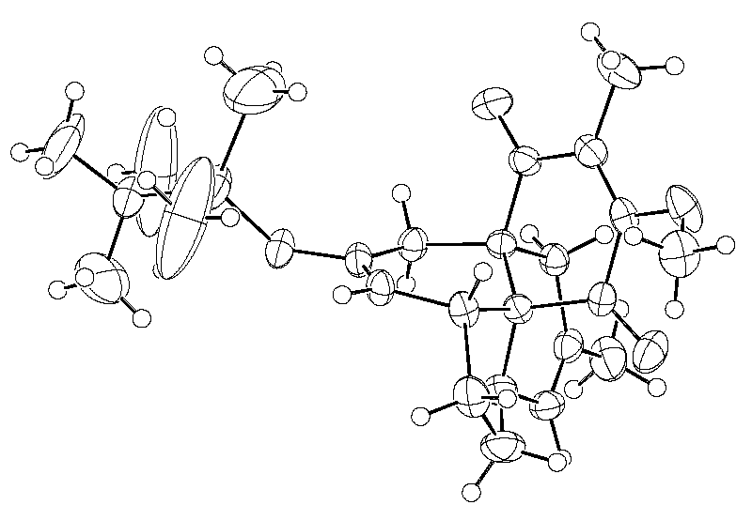

Figure A: Anisotropic displacement ellipsoid plot for 17 (multi-site disorder in TBS group) and stick-diagram of perspective.
Unit cell: a = 7.82030 (10), b = 25.1258 (3), c = 12.4625 (2) Ǻ, β = 92.8517 (5)°, V = 2445.74 (6) Å³, T = 200 K, space group P2₁/n
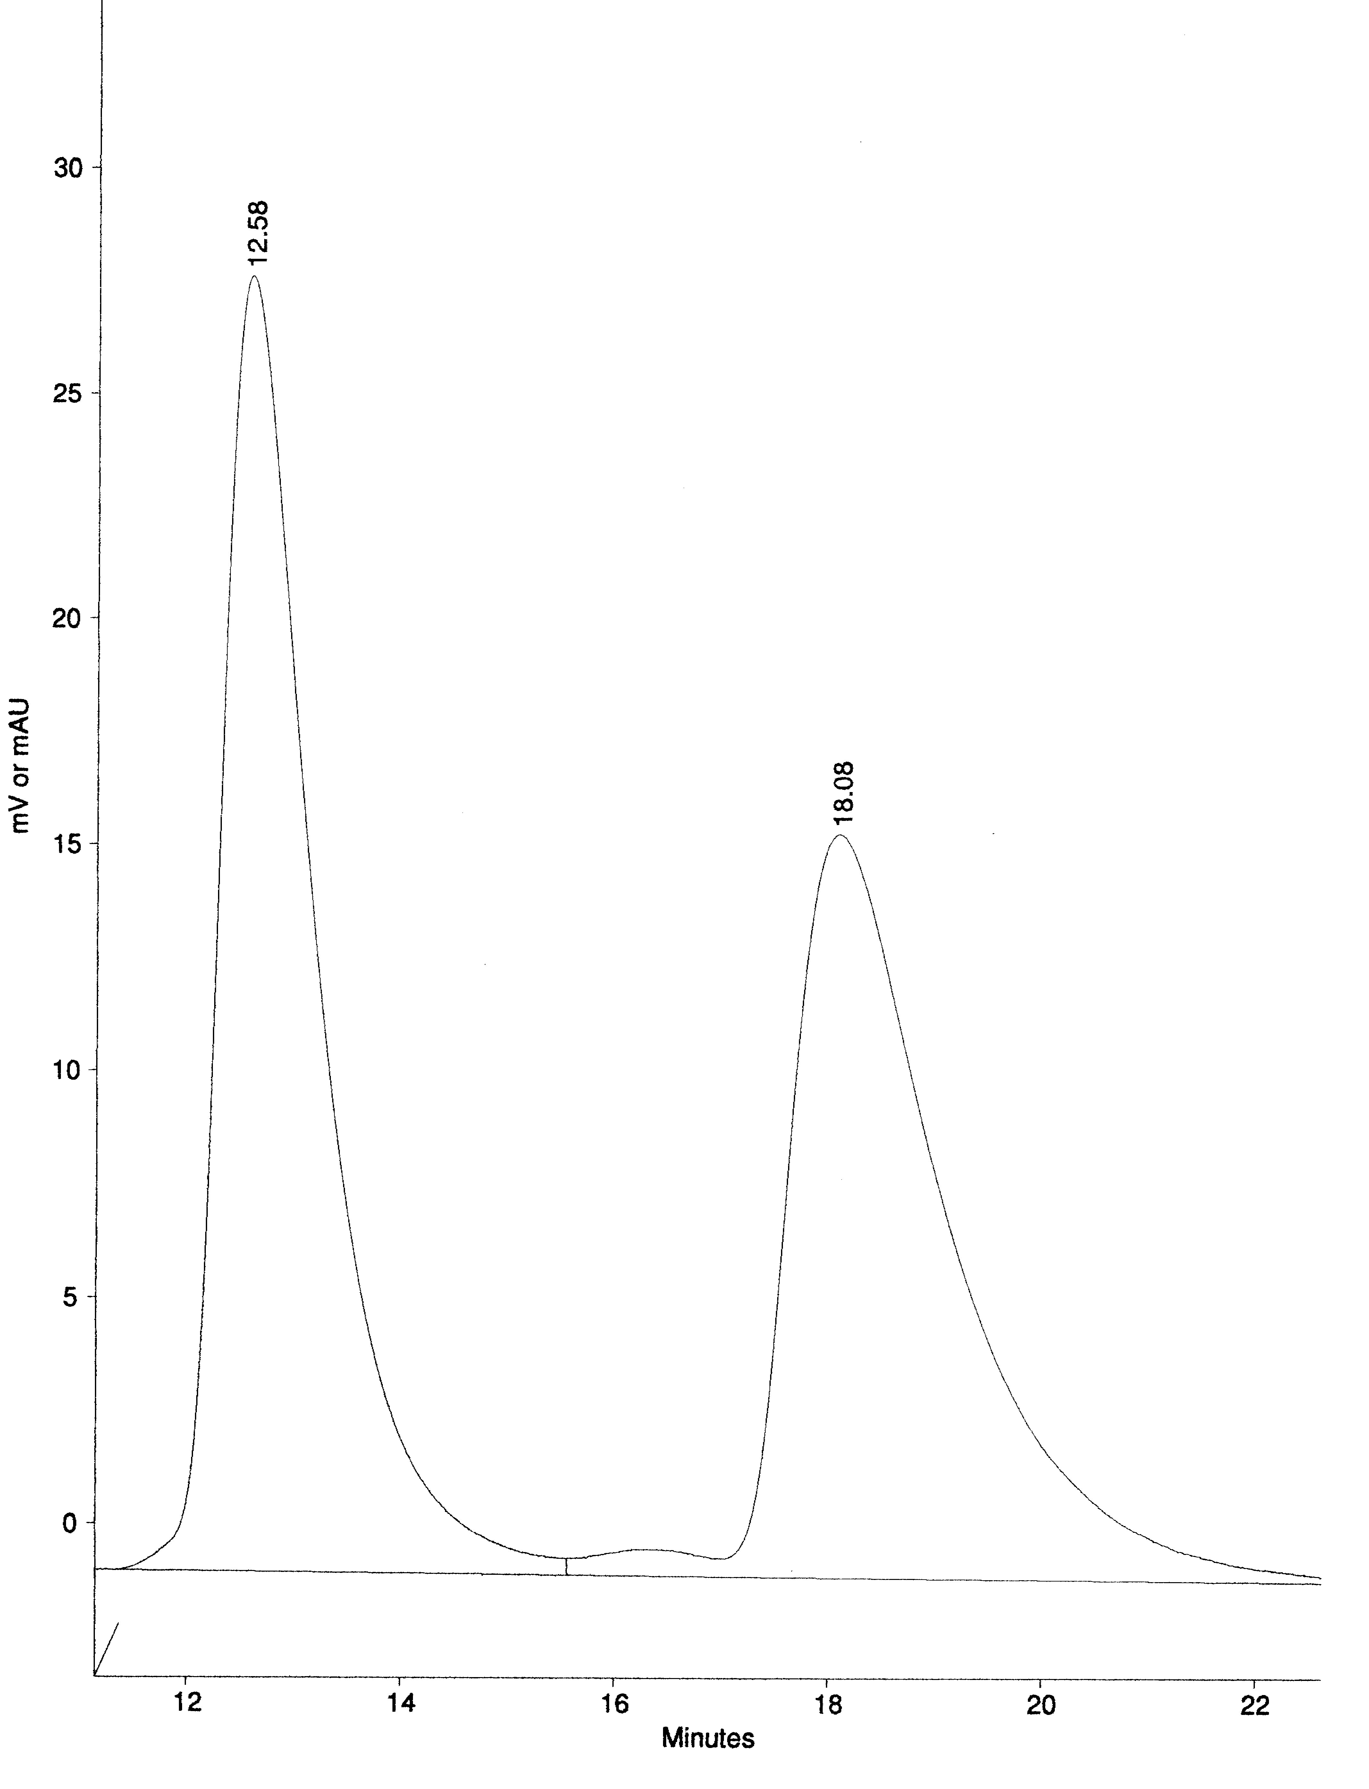
rac-17
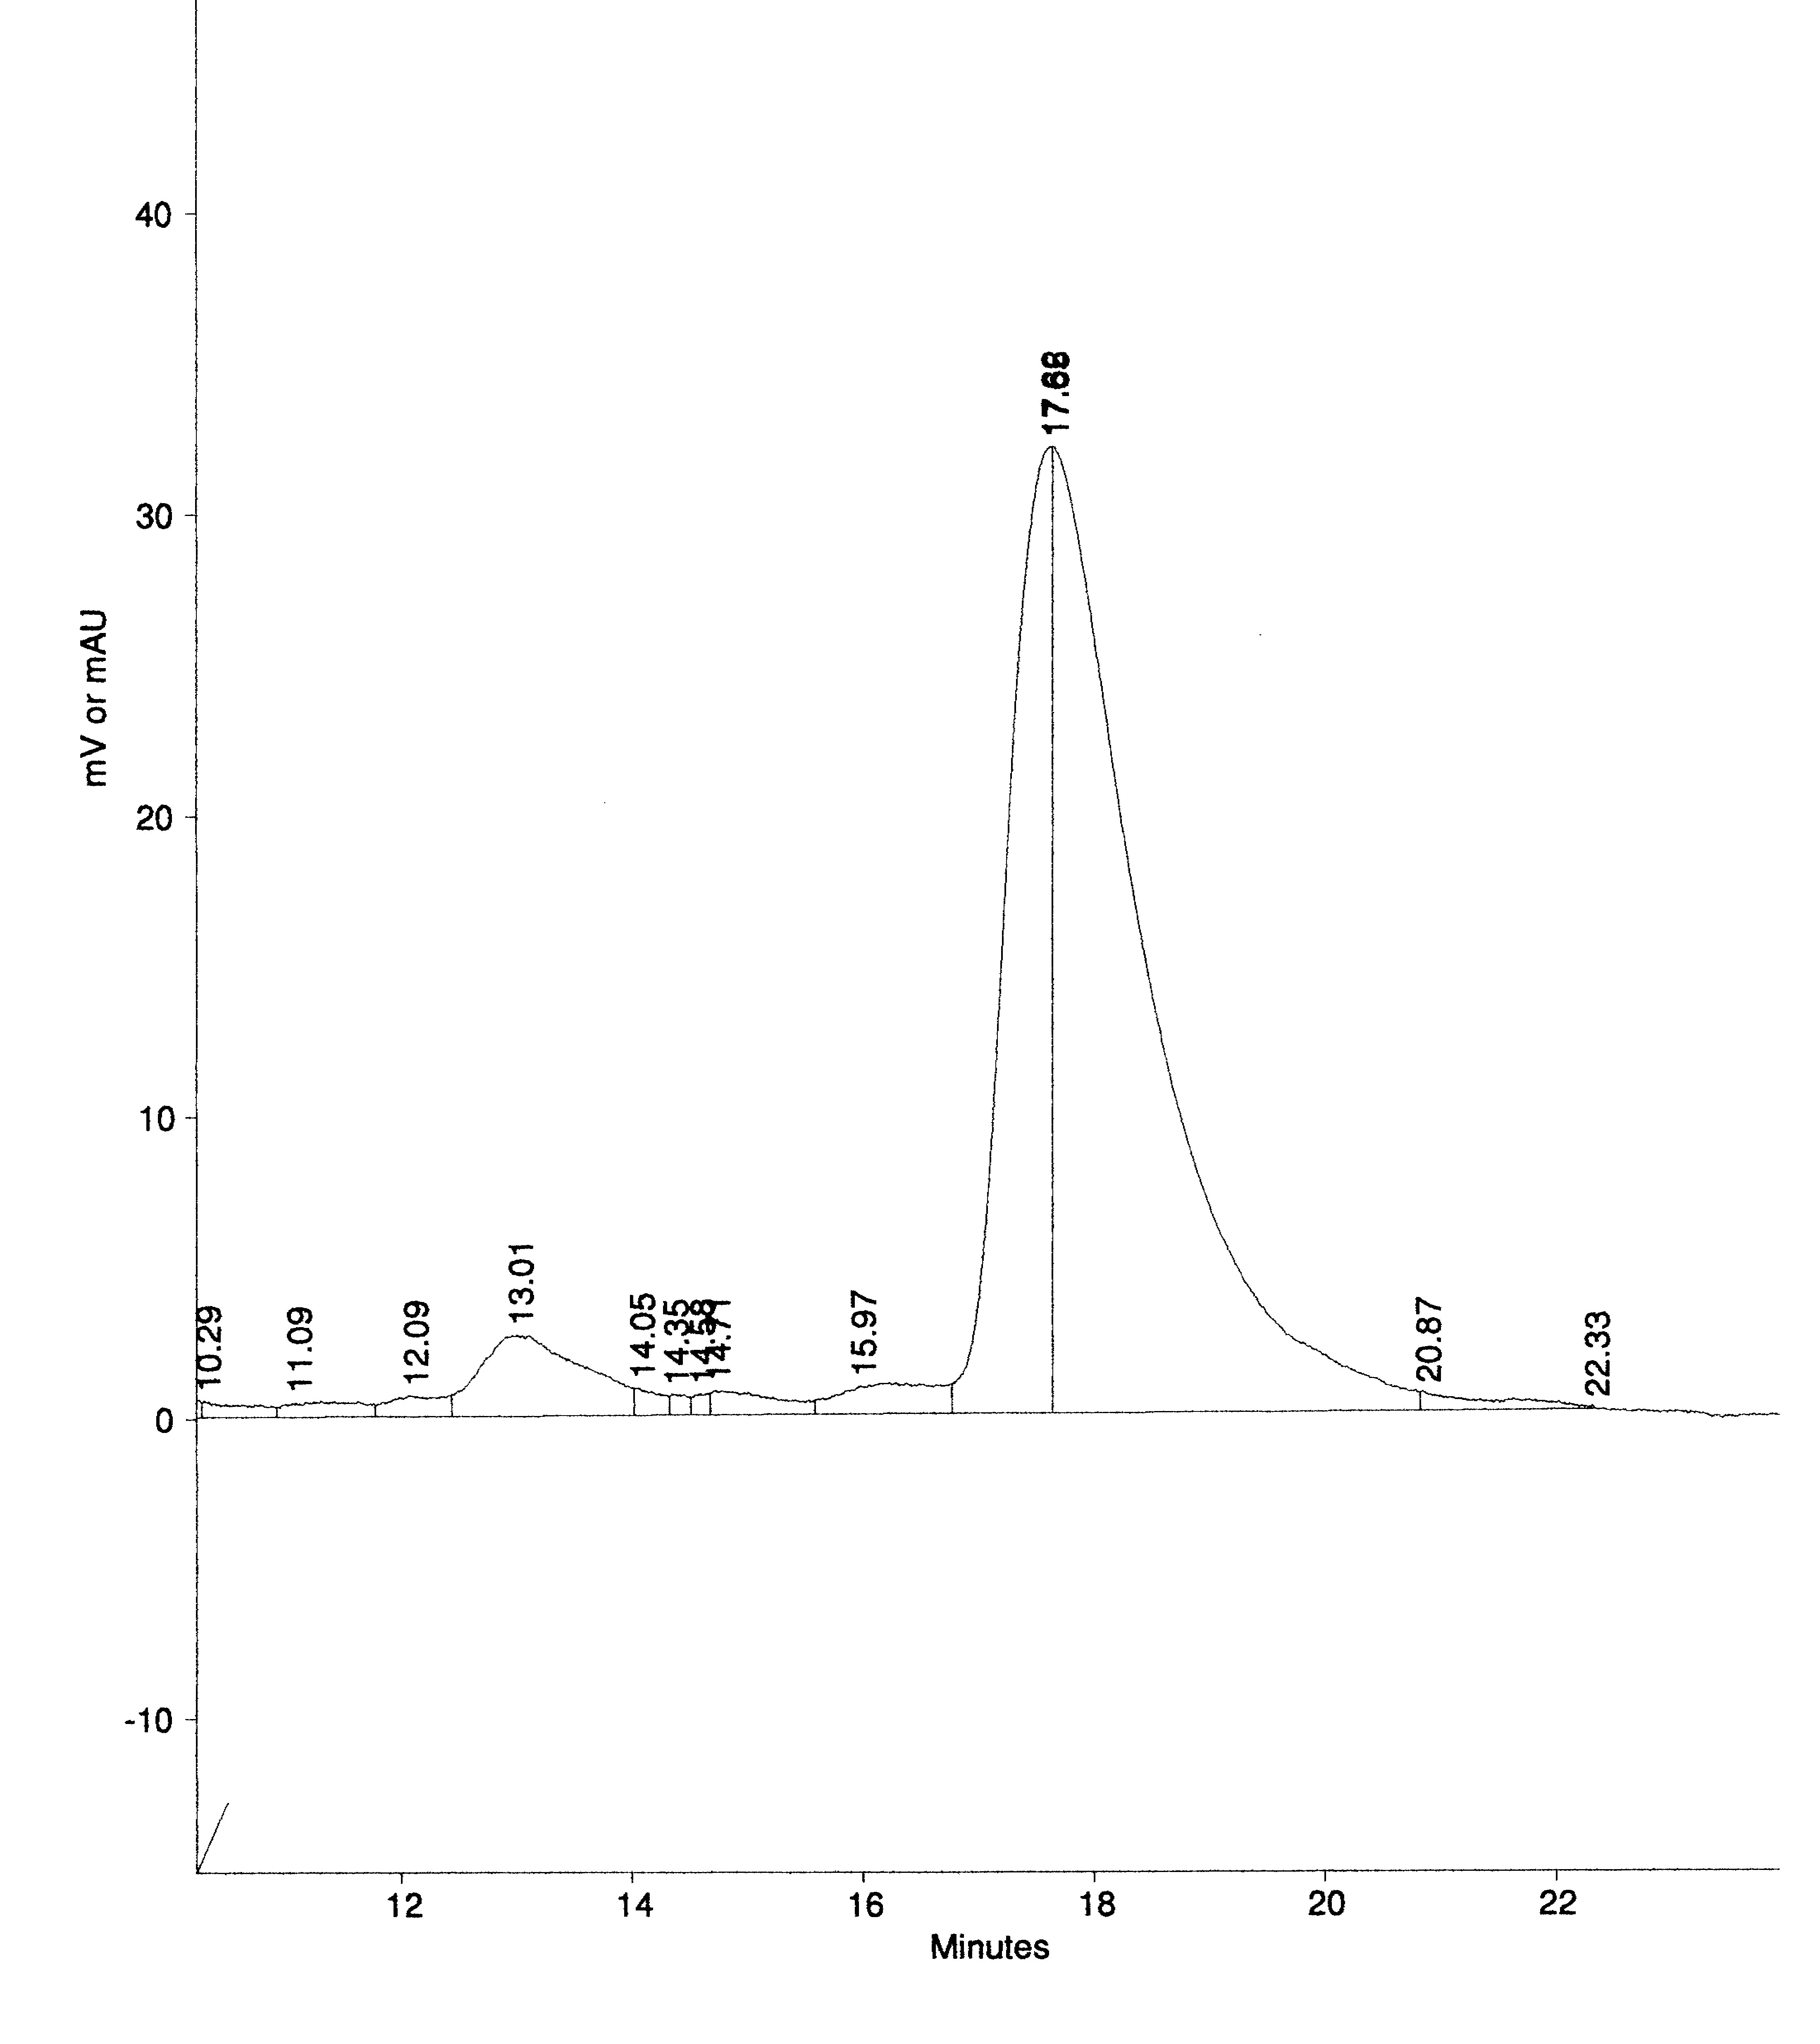
(-)-17
Figure B: HPLC traces of rac-17 and enantiomerically enriched (-)-17, using a Chiracel OD column (25 x 0.49 cm) eluting with hexane using UV detection (254 nm).

